AWS Certified: Solutions Architect Associate

Resource Links

1. AWS Certified Solutions Architect Associate Challenge Website  
( With all preparation Resources ):-  
  
<https://pages.awscloud.com/GLOBAL_TRAINCERT_takethechallenge_resourcehub.html#LearnPrepare>

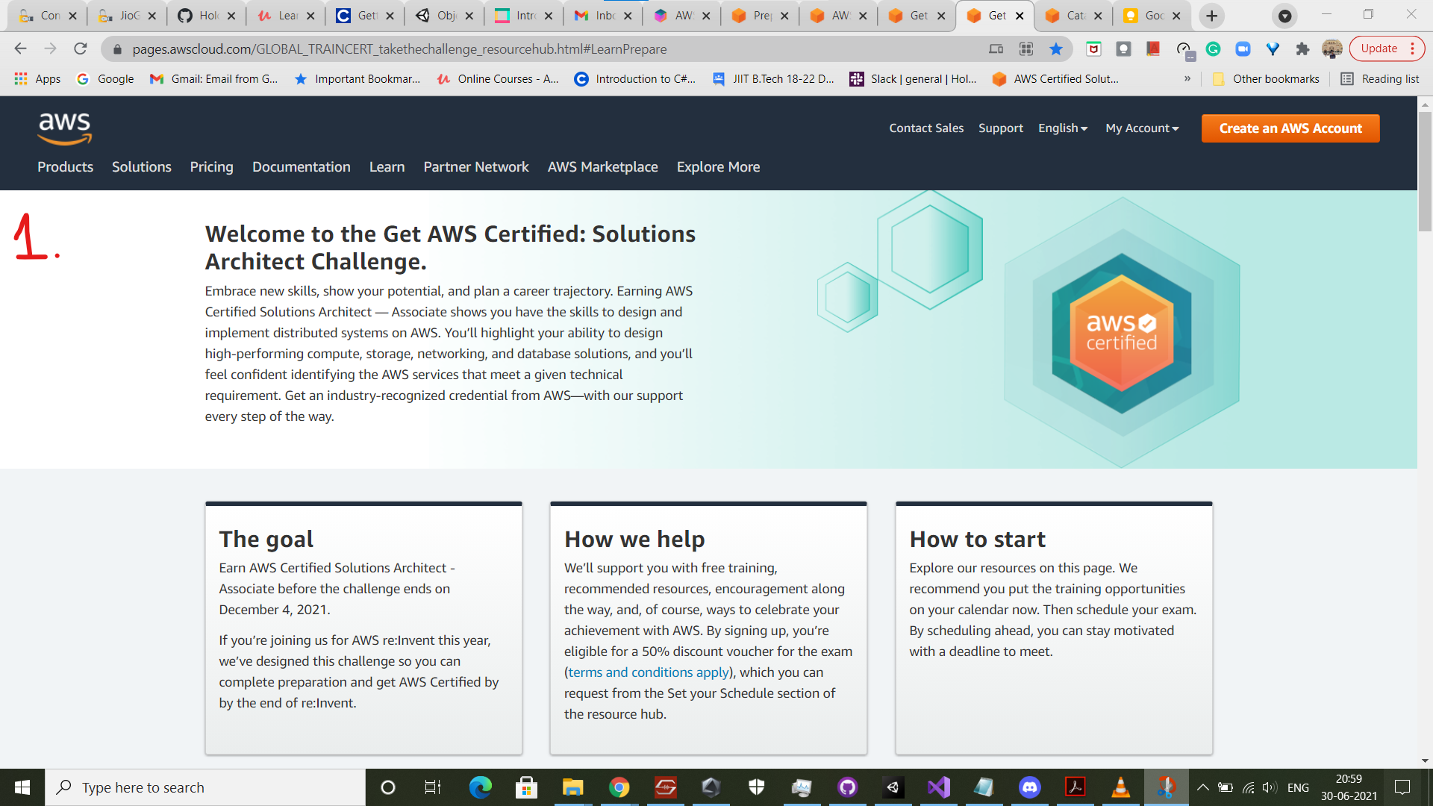

- - - - - - - - - - - - - - - - - - - - - - - - - - - - - - - - - - - - - - - -

2. Guide:-   
  
<https://pages.awscloud.com/Exam_Preparation_2020_Developer.html>

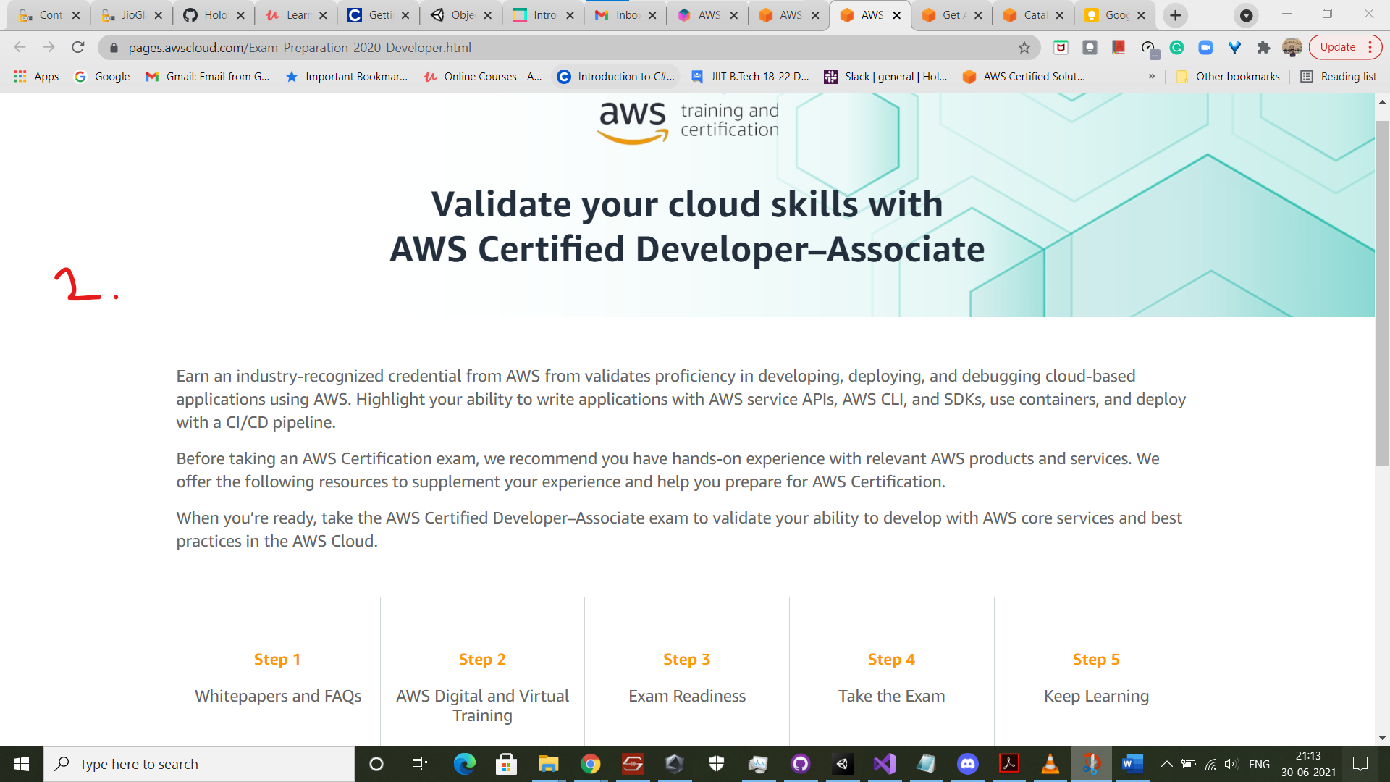

- - - - - - - - - - - - - - - - - - - - - - - - - - - - - - - - - - - - - - - -

3. AWS Certified Page, AWS Online Summit:-  
  
<https://summits-india.virtual.awsevents.com/channel/t/207306083?nc2=indsmt21_nav_tc_getc>

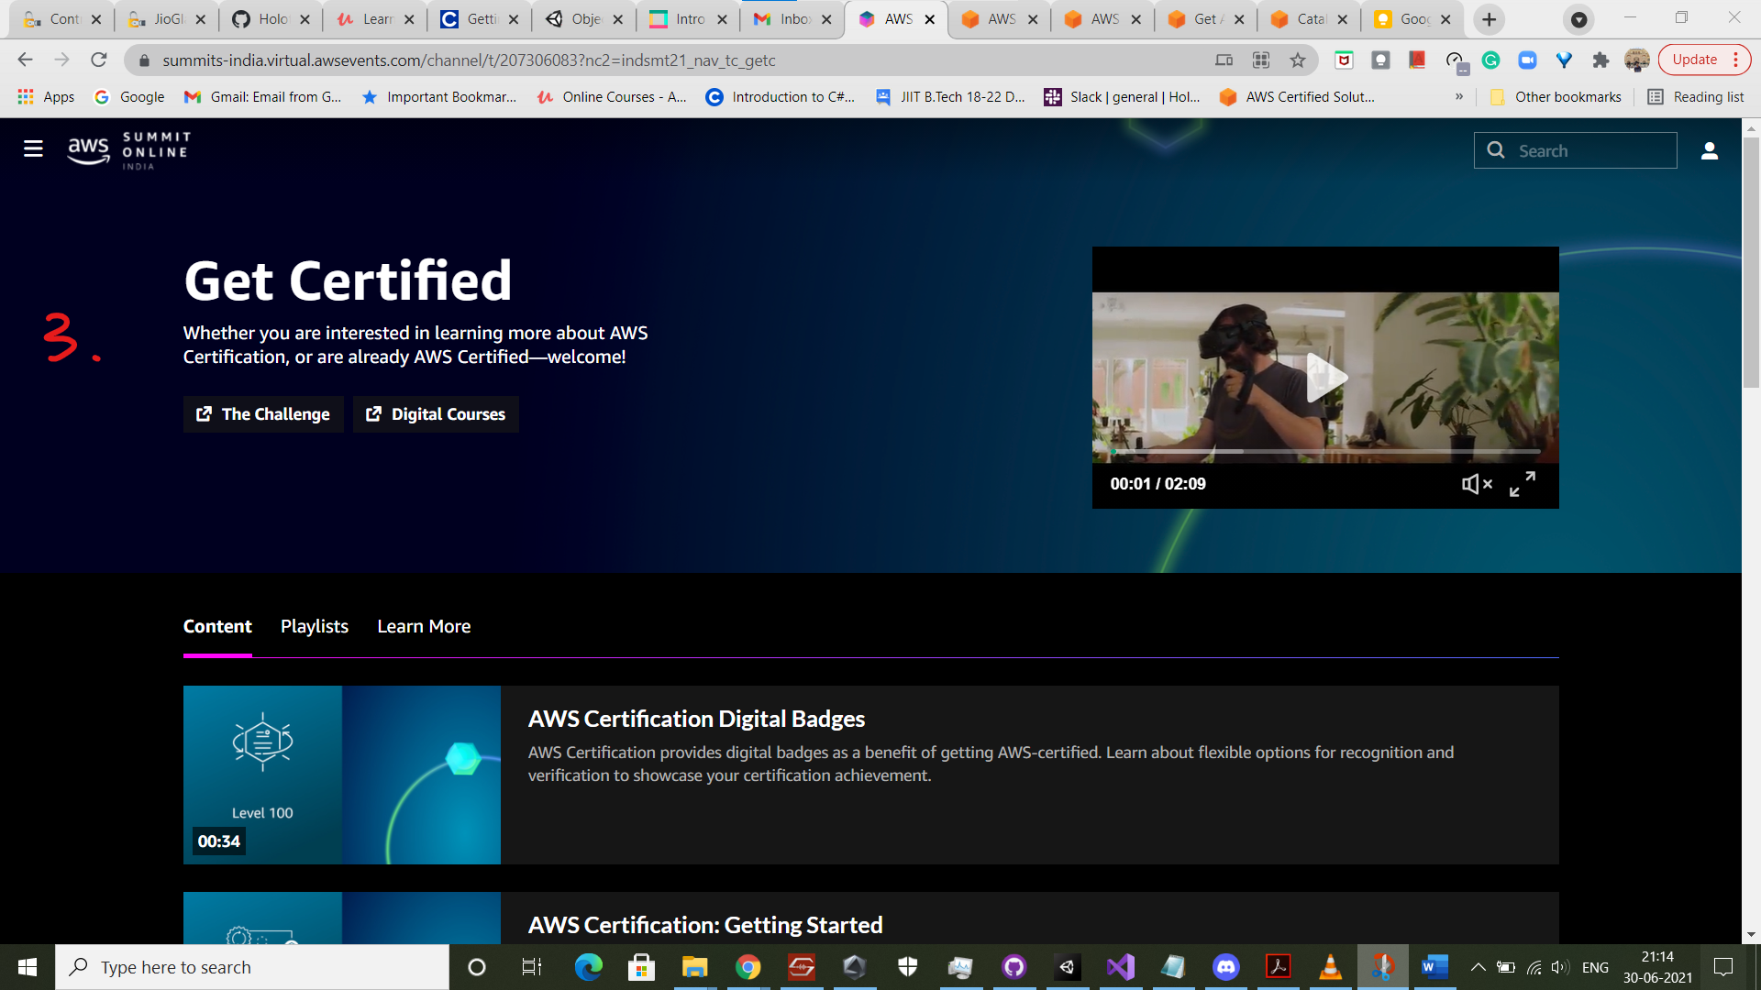

- - - - - - - - - - - - - - - - - - - - - - - - - - - - - - - - - - - - - - - -

4. Video Resources for Preparation, AWS Online Summit:-  
  
<https://indiasummit21.events.training.aws.a2z.com/catalog?certifications=SAA-C02>



                                       